Organic-mineral sorption materials on the basis of saponite clay

Widespread and indispensable growth of natural adsorbents use is caused by the fact that they, having developed specific surface and good (often specific) bleaching peculiarities, are dozens of times cheaper than artificial adsorbents. It leads to simplification of its usage technology – they often exclude the regeneration stage from the scheme. Saponite nature modification has been made with use of poly-organic-siloxane Ultratex and Tubingal that differ from regular organic polymers with a number of specific peculiarities conditioned by their chemical composition. Along with hydrophobic behavior, silicone compounds give saponite clay high rate of melting and, the important thing, don’t lower adsorbent capacity. There exist two distinctly different points of view on the nature of bond of mineral surface – silicone.According to the first point of view – physical, silicone material (of poly-alkyl-siloxane type) remain on the surface via purely mechanical way. According to the second point of view, the bond of mineral-silicone surface is of chemical nature and is caused by interaction of silicone materials with functional groups of clay surface. Adsorbent modification lies in covering the surface of sorption material with a layer of other substance that holds tightly due to force of adsorbent.

Such modification enables effective regulation of different saponite features, including physical-chemical, namely adsorbent activity, lyophily; structural-mechanic – viscosity, sedimentary and aggregative stability of suspensions; pharmacy-biological – biocompatibility, proteonectic and osmotic activities. At its final point, the aim of adsorbent modification is to create monomolecular or submonomolecular cover on the surface of clay material (fig. 1).

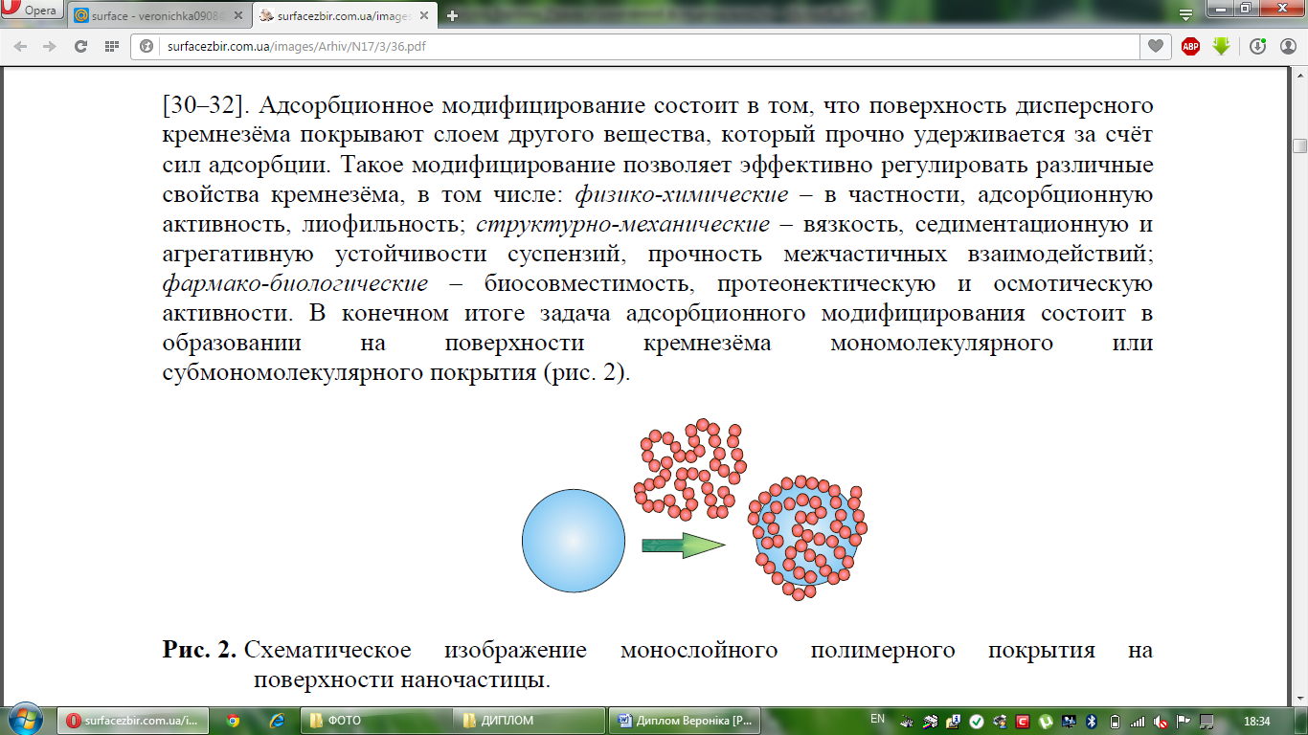
Figure 1. – Schematic depiction of monolayer polymer cover on the surface of clay material
The research of elemental composition of natural bowligite was done with analyzer EXPERT 3L. The obtained data showed the following elemental composition in the saponite structure of Tashkivs’ke deposit (mass %) Ti – 0,4-0,6; K – 0,3-0,9; Ca – 0,8-2,2; Mg – 5,9-7,2; Al – 6,6-7,9; Fe – 6,7-17,0; Si – 18,5-22,3; O – 46,8-59,0. Physical-chemical features of saponite have been researched: outer specific surface (for fraction of 0.053 mm) - 1037,1 - 1079,7 m²/kg; swelling capacity – 2,0%; colloidality - 11,7 - 12,7 %; volume of cation exchange – 54, 8 mg. eqv. On 100g. As quantity characteristics of hydrophobic behavior rate of the researched samples, marginal angle of moistening of their surface with water was measured. The outcome data: θ = 52,5⁰ and 38⁰ for natural and acid-activated-saponite, modified Ultratex, angle θ = 56,5⁰ and 32,5⁰ – modified Tubingal. Adsorbent features of saponite have been researched, sorption kinetics has been analyzed, hydrogen index, moisture contents and volume of sorption voids have been evaluated by exsiccator method. Changes in the structure of clay have been analyzed with infrared spectroscopy. Comparative analysis of the existing and improved technologies of hydrophobization of natural clay materials has been conducted. As a conclusion, the obtaining of organic-mineral sorption materials on the basis of saponite clay enables to use them as fillers of polymer environment and fluidizing agents, as well as in production of oil sorbents.

